ROBERT ANCHIPOLOVSKY (ISRAEL)

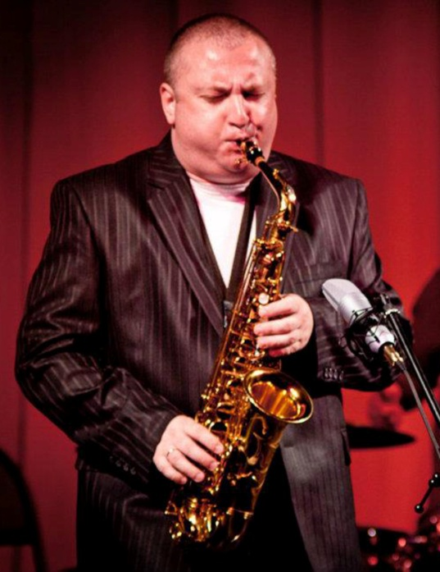
He started practicing the classic music of Mozart, Weber, Shpor, etc. In 1982 he has started to practice at music college in Kiev. In 1988 Robert has started to practice alto saxophone because he loved jazz music more, and of course, he loved the music of Charlie Parker and John Coltrane.
He continued learn at academy of jazz music in Kiev. In 1991 Immigrated to Israel. In 1992-1996 Studied in New York under direction of Mr. Phil Woods. In 1996 back to Israel since then he has formed and lead several bands in the country. Since 2002 Robert Anchipolovsky working in popular international television Show "7:40"
He continues to participate in jazz festivals all over the world and his career includes work with legendary musicians from the first line such as: Phil Woods, Valery Ponomarev, Randy Brecker, Brian Linch, Larry Willis, Curtis Fuller, Stive Turre, Mulgrew Miller, John Hicks, Jim Rotondy, Deborah Brown, Kevin Mahogany, Dena Derose, Kirk Lightsey, Odean Pope, Tecora Rogers.
Taking jazz on traditional main-stream, Anchipolovsky has established himself as a virtuoso instrumentalist, a brilliant performer and an artist passionately committed to his music. The intensive concert appearances were combined with musician's participation in big jazz contests. Robert Anchipolovsky plays with powerful intensity, sophisticated technique and remarkable sensitivity. He is constantly continuing to innovate and to renew his repertoire and styles.
While in Europe,he has performed and recorded with some of the finest European musicians such as: Tony Pancella, Pietro Iodice,Massimo Moriconi, Massimo Manzi, Bepi D'Amato, Max Ionata, Igor Butman, Leonid Ptashka, Jamie O'Donnell, Ruslan Sirota, Sergey Vasiliev, Igor Nadezhdin, Daniel Kramer.
READ MORE – https://sites.google.com/site/anchipolovskysax/biography
https://www.youtube.com/watch?v=rmRi3dBKbr8
https://www.youtube.com/watch?v=6kDJvp4NQF4

